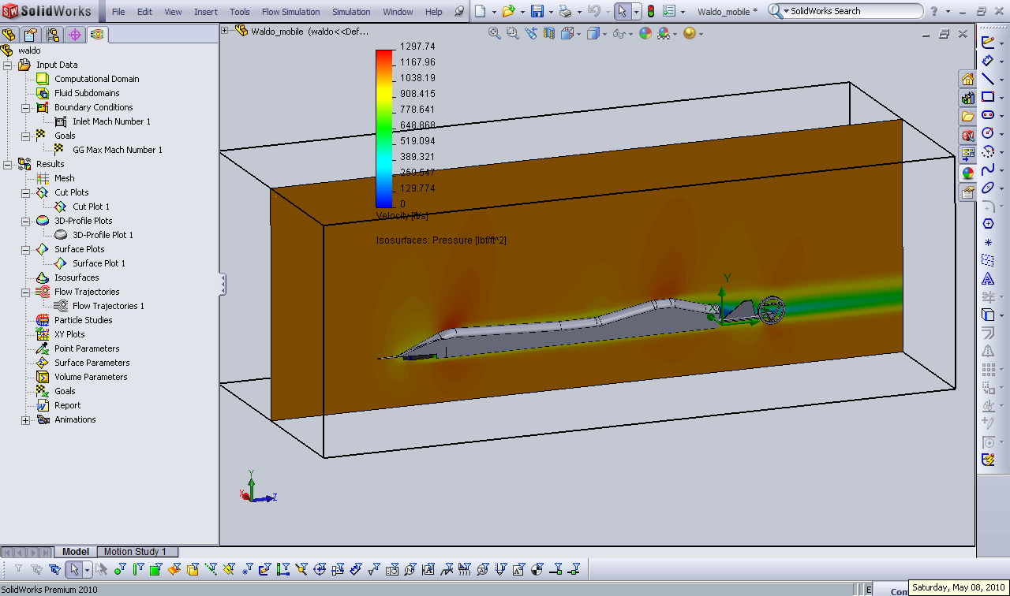
Fig-1: Velocity Distribution over the body at M = 1

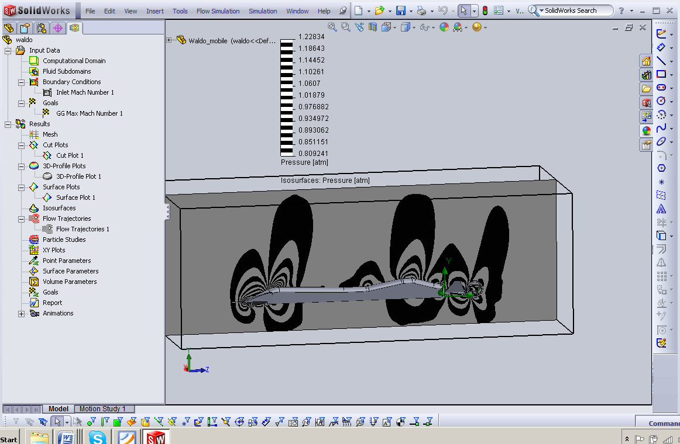
Fig-2: Pressure Distribution over the body at M = 1; These are areas that create un-balanced forces on the body

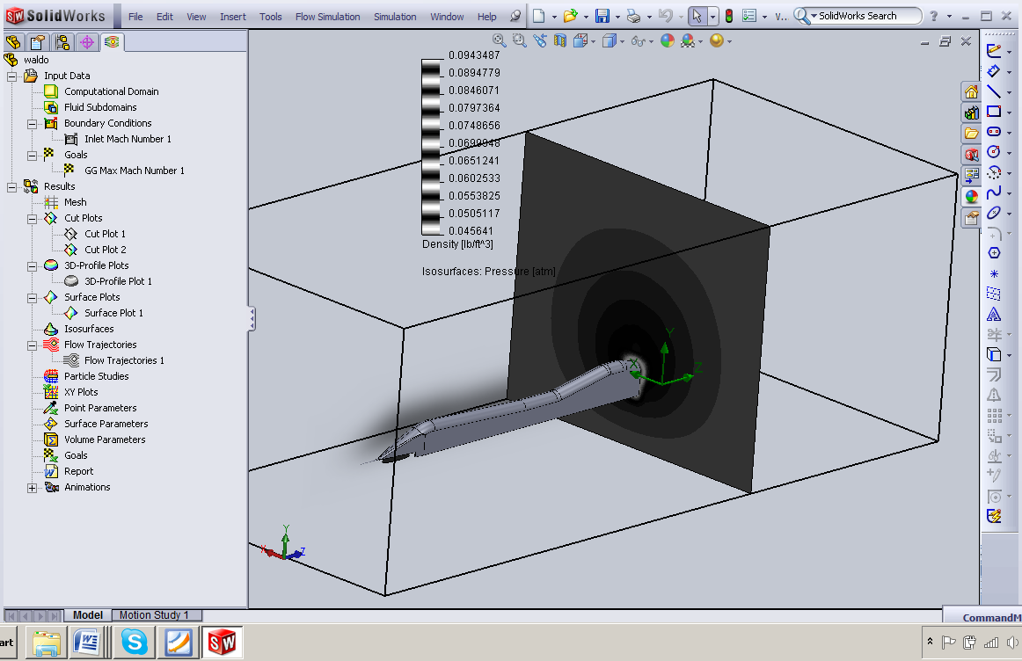
Fig-2: Density Compression near exhaust at M = 1

